Overview
There are two distinct portions to the close process in NetSuite. First the AR, AP and GL must be locked, then the additional areas must be finalized.
Checklist
NetSuite walks you through a checklist for the close process. To access the checklist, go to Setup>Accounting>Manage Accounting Periods. Next, click the magnifying glass next to the period you are ready to close. You are presented with a Checklist that has the following items:
- Lock A/R
- Lock A/P
- Lock All
- Create Intercompany Adjustments
- Revalue Open Foreign Currency Balances
- Calculate Consolidated Exchange Rates
- Eliminate Intercompany Transactions
- Close

Locking Modules
- Each Subsidiary can have the AR/AP/All locked independently.
- AP and AR can be locked independently of each other, but the Lock All cannot be locked until the AP and AR have been locked.
- Click the Arrow button on the left of the item you wish to lock, select the Subsidiary you are locking, and click Submit.
- After either the AP or AR Lock is completed for all subsidiaries, a critical step is required to ensure that Integration with Apto works properly as well as certain non-GL Impact to transactions can be adjusted.
  - Click on the Period Name, Check the Box “Allow Non GL Changes”
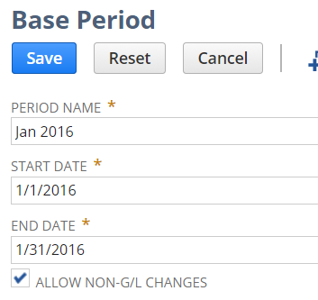

Additional Close Tasks
- The remaining items are global, and cannot be done per subsidiary.
- Each Item following Lock All must be done in the order listed.
- Click the Arrow button on the left of the item you wish to lock, click the “Create XXX” for the item, and review any results.
  - Once confirmed items are accurate, click Submit.
  - Ensure the Posting Period is correct, then Submit again.
  - If there are no items, click Back to Period Close, click Mark Task Complete.
- Continue with this process for all the items including Close.

