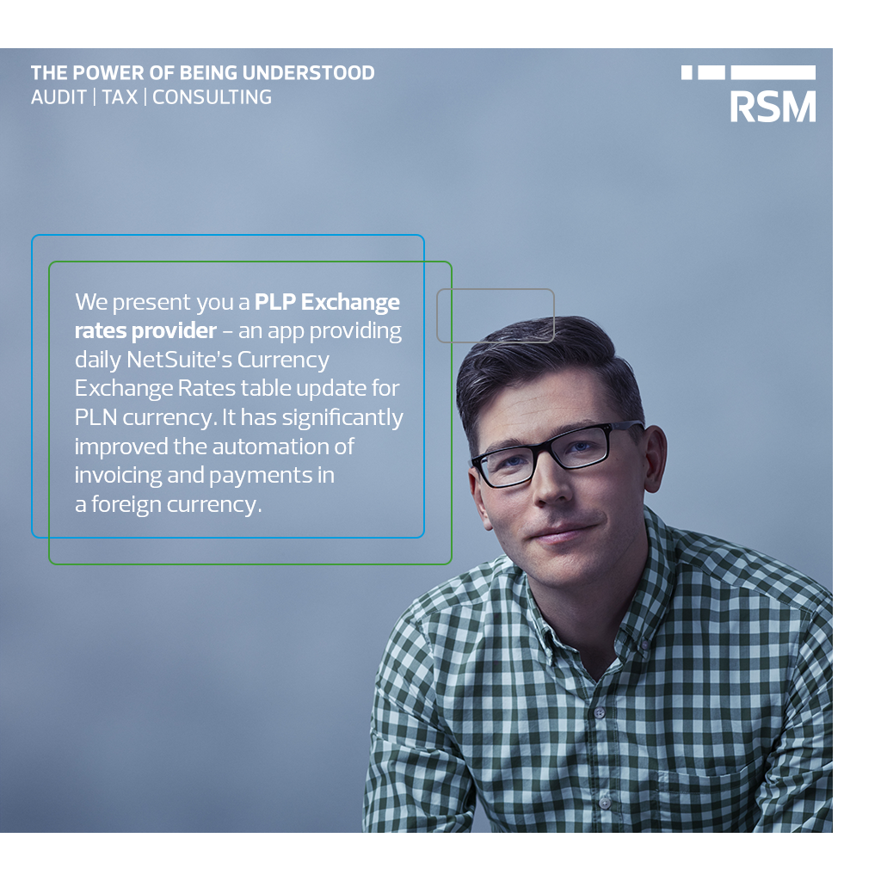

PLP Exchange rates provider

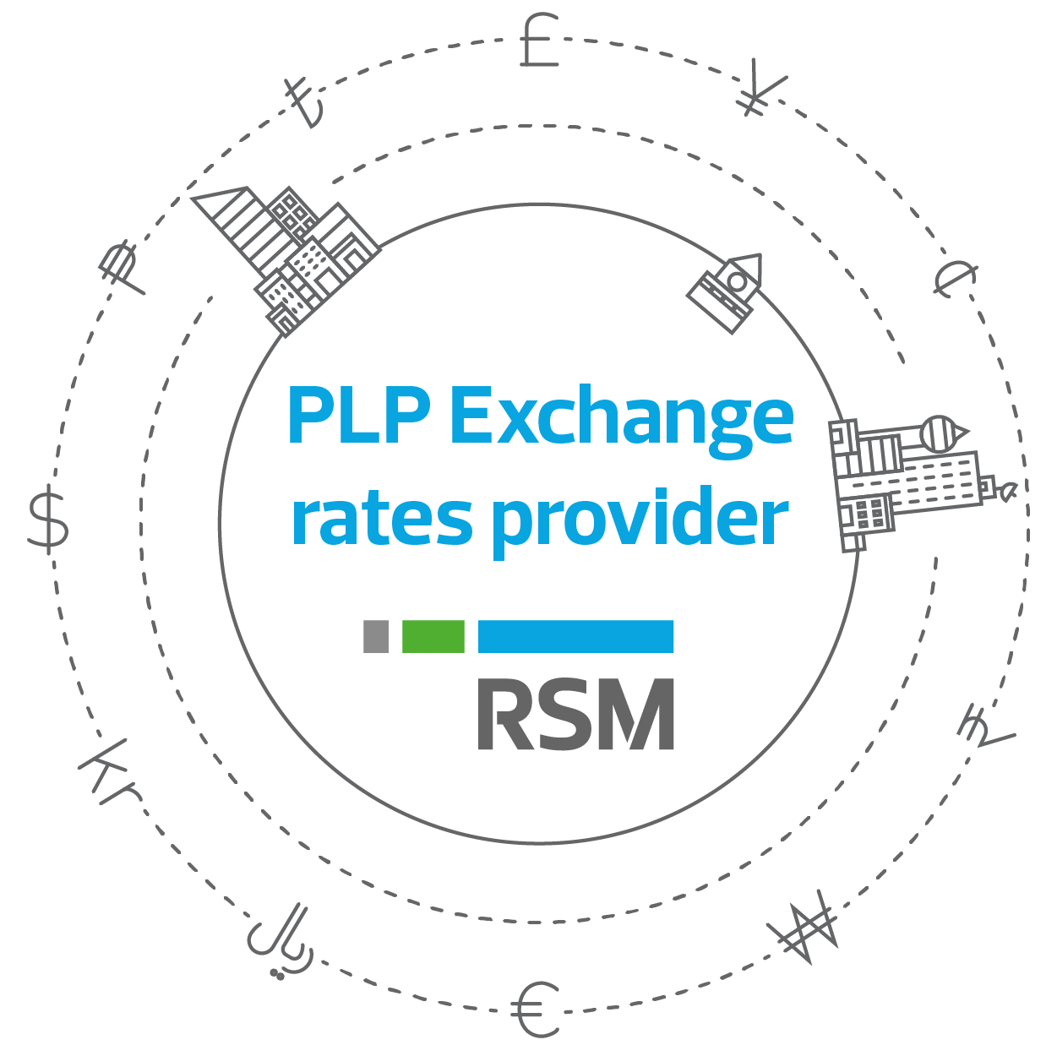

This bundle contains scripts which provides daily NetSuite’s Currency Exchange Rates table update for PLN currency. Exchange rate values are downloaded from official National Bank of Poland web service using its public Application Programming Interface.

Key Benefits

- Time zones
- Currencies
- Mass imports
- Protection against web service dysfunctions & fail script execution
- Bundle configuration

Time zones

The script may work safely in each time zone. Because the script is scheduled for daily update, it is important to determine what day is currently at your business and what day is actually in Poland because NBP publishes exchange rates values labeled with dates formatted like it is preferred in Poland. It does not matter what time zone is in your subsidiary from the configuration point of view because the script will automatically detect the time zone and apply a suitable time shift.

Currencies

The script will put/update in the Currency Exchange Rates table only these records whose have Base Currency equal to PLN, what is obvious. NBP publishes two major tables – A and B. The first one is generally published on each business day and the second one is published on average once a week. In the table A there are exchange rates for many of the most common used currencies in the world and in the table B there are exchange rates for much rarely used currencies.
The key is that you mustn’t care about what table actually contains the certain currency you have in use. The script can search for exchange rates both in table A and B for all currencies you have created in NetSuite for your business and load them all. If there is no matching currency in the table A, nor B, then this exchange rate will not possible to be updated.

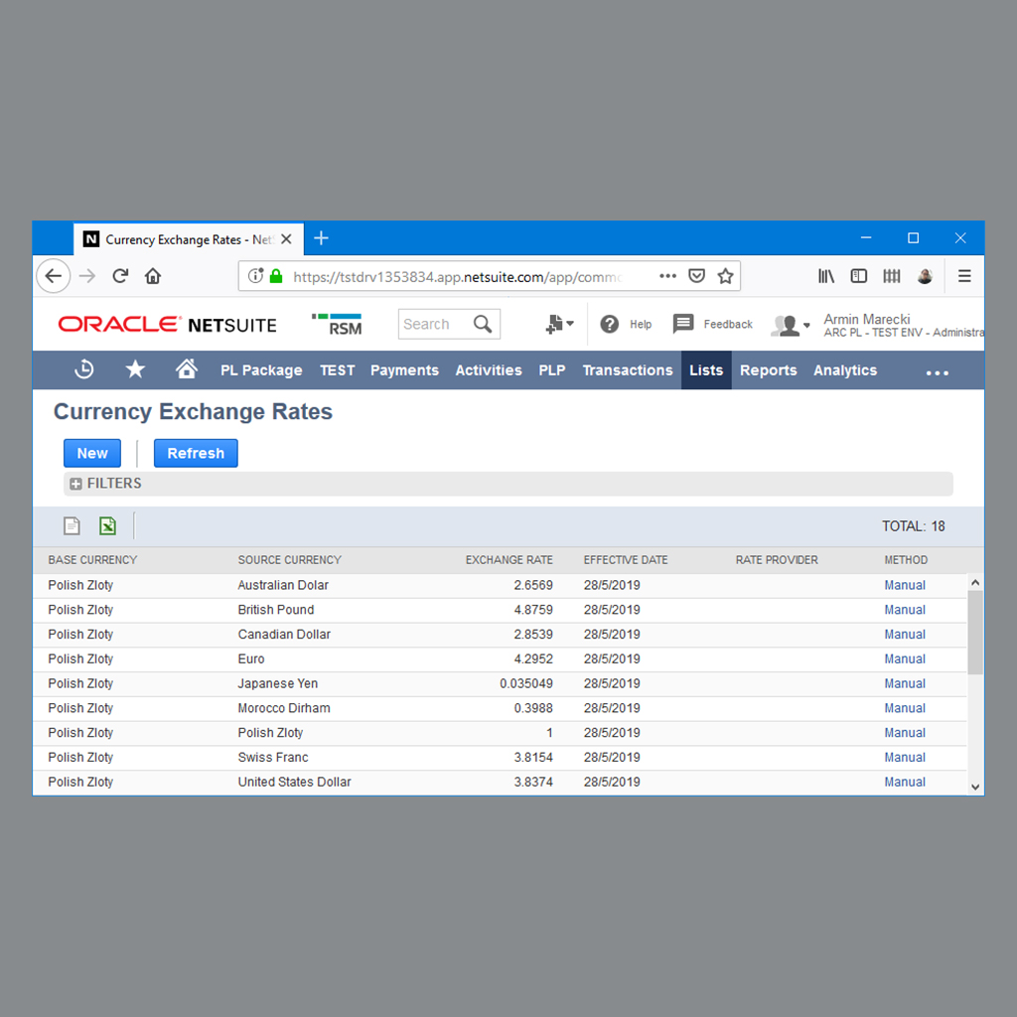

Bundle configuration

This bundle can be configured in PLP Exchange rates provider setup custom record.

- Fetch the data from the table A/B
- Perform an everyday import
- Store last CSV import data

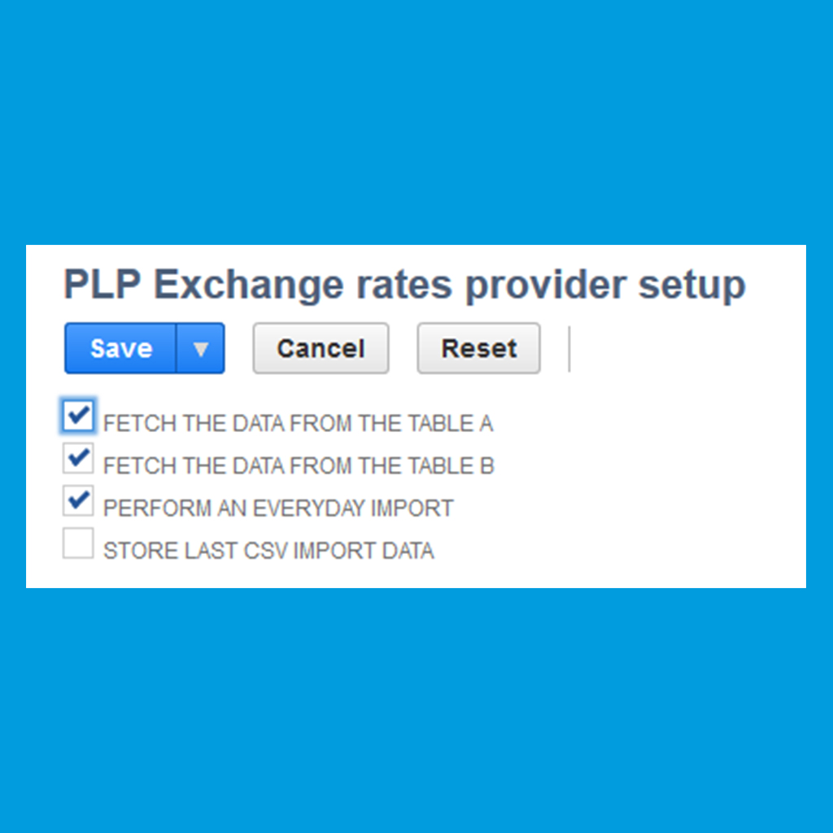

Scripts on each execution may store also some additional information gathered from NBP like table no. and type in the PLP Currency Exchange Rates custom record. These data may be used in cooperation with other PLP bundles, for example PLP Invoices & Corrections. Those information may sometimes be very useful when you’ll need to show from which table you took a certain exchange rate value for a specific transaction. PLP Invoices & Corrections bundle scripts use this data to display NBP table type & no. on polish Invoice & Credit Memo prints.

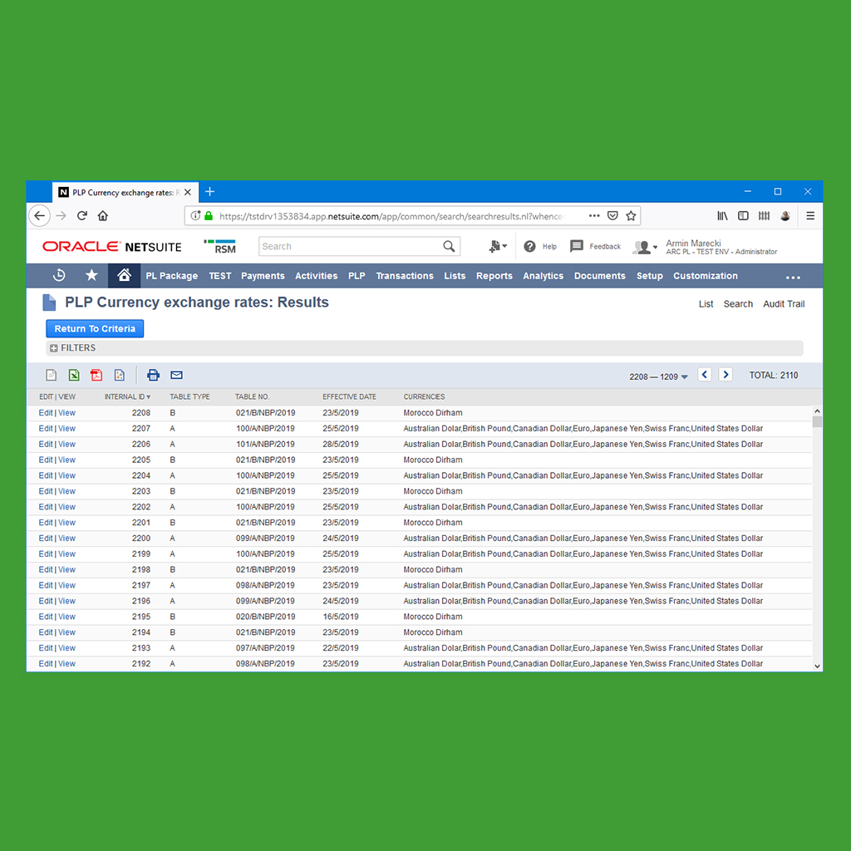

Mass imports

If your business does need an exchange rates mass import, the script supports downloading exchange rates for any wide, arbitrarily determined date range. You can download even historical exchange rates as long as they will be still accessible via NBP API.

Protection against web service dysfunctions & fail script execution

If the National Bank of Poland web service will be temporarily unavailable for some reason during the Scheduled Script execution then there is no reason to be afraid. The script deployment stores last successful execution date and performs a mass import starting from this day up for today (yes, this uses the same date range parameters which can be used in mass import procedure). Every time the script execution fails due to something, the last successful execution date will not be updated, therefore during the next scheduled execution all missing exchange rates will be imported into NetSuite.

Technical notes

By default, the scheduled script named PLP Exchange rates provider script (identified in NetSuite with script and deployment identifiers pair customscript_plp_exchange_rates_provider and customdeploy_plp_ex_rate_provider) is executed daily at 9:30 PM UTC+1:00. This is a recommended schedule because it is after the latest exchange rates table is already being published (usually about 12:30 AM UTC+1:00 every business day), during off-peak hours in Poland and before any planned night NBP servers maintenance.

