NetSuite Oracle Training
Click Below link for library of Oracle NetSuite Training.

NetSuite Online Training

NetSuite Basic Usability - Check these recordings out on NetSuite Basics.
Introduction to NetSuite
- Intro to NS
- NS Core Business
- Navigation
- Security
- Roles
Dashboard & Portlets
- Dashboard Overview
- Add/Remove Portlets
- Rearrange Portlets
Tools and Reminders
- Reminders
- Personalize the Quick Create Tool
- Add Shortcut
- Review Recent Records
- Work in the File Cabinet
User Preferences
- Review User Preferences
- Set User Preferences
Global Preferences
- Conduct a Search
- View Search Results
- Use Wildcards
- Use Prefixes
List & Records
- Lists
  - Navigate to a List
  - Adjust List Views, Filters, and sorts
  - Edit List Records In-Line
  - Export List Result
- Records
  - Access Records
  - Review Record Features
Reports & Searches
- Access Reports
- View, Filter and Format Reports
- Export and Email Reports
- Access Saved Searches

Help Resources
- Access the Help Center
- Use SuiteAnswers
- Use Field Help

NetSuite View Reporting
Audience: New to NetSuite
NetSuite View Reporting (41:33)
- Access Reports
- Views and Drill-Down
- Tools & Filters
- Exporting and Scheduling Reports

Financials
Overview
- Financial Management Tools
- Dashboards
- Report & Analytics
Financial Segments
- Overview
- Create New Segment
- Assign Segment to Transaction
- Group & Filter Reports Using Segments
Chart of Accounts
- View the Chart of Account
- Create New Account (See Zendesk Guide – for process to request new Accounts)
- View an Account Register
Journal Entries
- Create Journal Entry (Note – AY Customized this page)
- Approve a Journal Entry
- Memorize a Transaction

Order to Cash
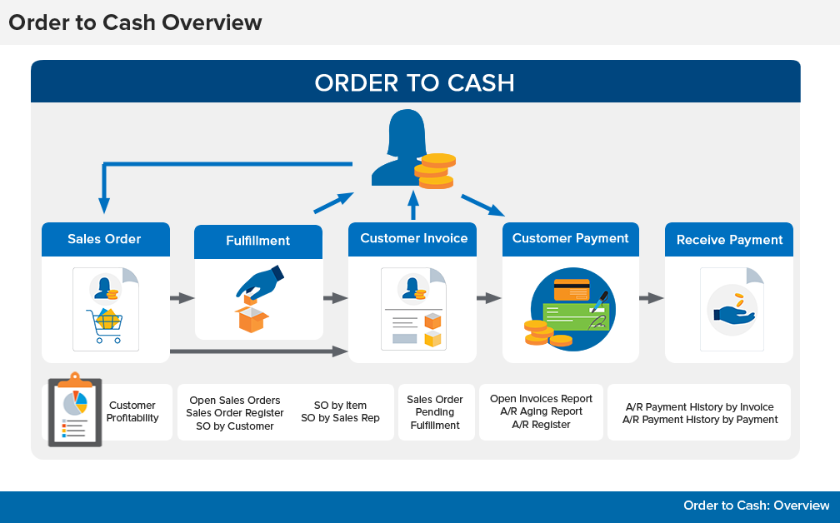
Reports Delivered by NS

Overview
- NetSuite Order to Cash Process
- Utilize your Dashboards
- Identify Key Reports and Analytics
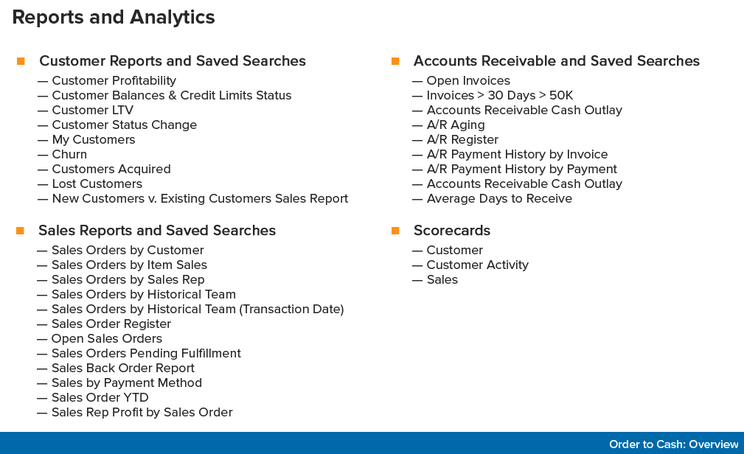
Customer Management
- Create Customer Order
- Create Customer Contact
- Customer Dashboard
Invoicing
- Create Stand Alone Invoice
- Create Invoice from Sales Order
- Create a partial invoice from an Item Fulfillment record (N/A to AY)
- Bulk Create Invoice
- Identify Key Reports and Analytics
Return To Credit
Return to Credit
- Create & Apply a Credit Memo
- Create a Standalone Credit Memo
- Refund a Credit Memo
Other NetSuite Training
Logging in & Best Practice Duration: 7 minutes | Audience: All users
See how to log in to NetSuite and set your password, the essential first steps to enabling your access to NetSuite:
- Log into NetSuite
- Set your default role and change roles
- Set your security questions
- Change your email or password

Navigating NetSuite
Duration: 12 minutes | Audience: All users
See how to navigate NetSuite's user interface (UI):
- Navigating the Home Dashboard
- Defining Centers, Tabs and Menus
- Working with Dashboard Portlets

Getting Help
Duration: 8 minutes | Audience: All users
See how you can use NetSuite’s multiple self-help features to get answers to your questions with just a quick click within the application:
- Use field-level help
- Access the NetSuite Help Center
- Navigate within the NetSuite Help Center
- Search in the NetSuite Help Center

Setting Your Personal Preferences
Duration: 20 minutes | Audience: All users
Make the NetSuite workspace meet your needs! Learn how you can tweak personal preference settings within the application to set:
- Calendar preferences
- General preferences
- Appearance preferences
- Transaction preferences
- Analytics preferences
- Activity preferences

Personalizing the Home Dashboard
Duration: 24 minutes | Audience: All users
A personalized Home Dashboard can make your day-to-day job much easier by presenting the information you need, right in front of you. See how you can personalize your Home Dashboard by:
- Adding portlets to your Home Dashboard
- Setting up key performance indicators (KPIs)
- Setting up Dashboard Reminders
- Creating shortcuts on your Home Dashboard

Using Quick Search
Duration: 7 minutes | Audience: All users
See how you can use Quick Search to quickly find and access records from your Home Dashboard:
- Add a Quick Search portlet to your Home Dashboard
- Customize the Quick Search portlet so you can search for your preferred record type
- Explain how to search for records using the Quick Search portlet

AY Learn
Excel Training

