NetSuite – Email Invoice Transactions Instructions – NON-BROKERAGE ONLY
Contents
Overview: 1
Prerequisite- SetUp Steps 1
Setting Email Attachment Format 1
Creating New or Modifying Customized Email Templates 2
How to Send Invoices via EMAIL 2
Option 1 – Sending email from Invoice 2
Option 2 – Sending email with Multiple Attachments 3
Sales Order – Invoice Attachment 5
Appendix – Global Settings 6
Bill-To Updates: 6
ADMIN TASK ONLY - Creating New Customized Email Templates – OPTIONAL 7

Overview: This new feature provides the ability to email invoices created in NetSuite for non-brokerage invoices.
The change is requested to improve the non-brokerage invoicing process by emailing invoices as soon as they are created in NetSuite. Currently invoices are printed and mailed via US Mail resulting in additional work, cost and delays in the bill-to receiving the invoice and processing it for payment.

Prerequisite- SetUp Steps
Prior to being able to utilize this feature you must setup the Bill To’s and your preferences to allow for this feature.

Setting Email Attachment Format
Next Setup the Email Attachment Format you want the document to be.

Note - This is user level preference; each individual user can set this and would be applicable to that user only.

- Navigation: Click on Home > Set Preference

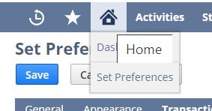

- Navigate to Transactions tab and select the format. Save Change.

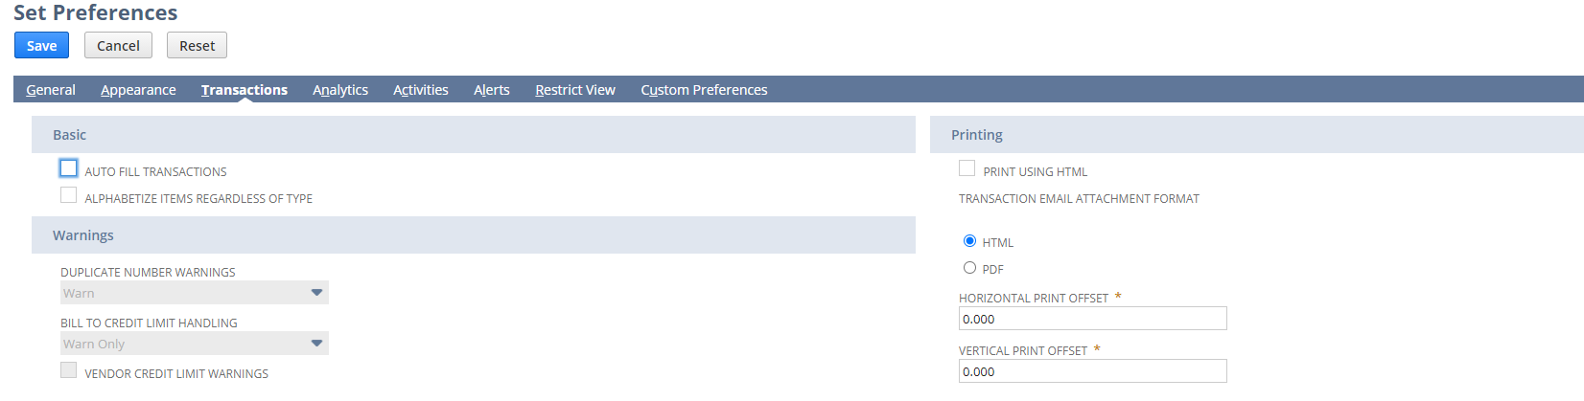

Creating New or Modifying Customized Email Templates
Please send in request to FinanceAppSupport@avisonyoung.com for changes to the Customized Email Template. The Finance Apps Support Team will work with you on the template.

How to Send Invoices via EMAIL

Option 1 – Sending email from Invoice

- Navigation: Click on Invoice Document > Communication tab.
  - Click on TO BE E-MAILED’ check box and assign an email address against it. If Bill To is defaulted to receive transaction emails, this would be checked by default.
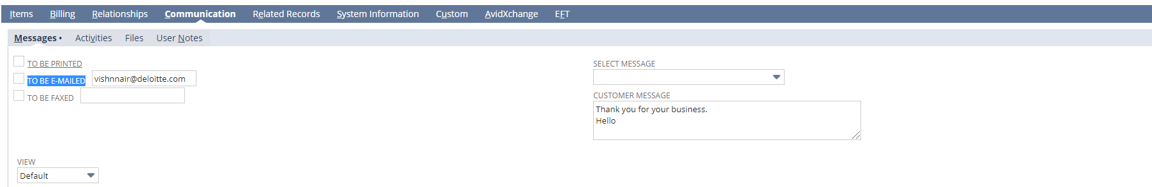
  - Once Complete Click On ‘Save’ and system would trigger an email to Bill To with invoice copy.
    - Alternatively, user can also click ‘Save and Email’
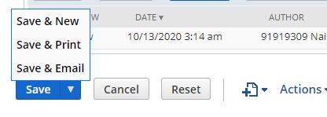

- Sent emails can be verified on Invoice transaction itself under same communication tab.

Option 2 – Sending email with Multiple Attachments

Navigate to Invoice> Communication tab.
- Click on Email
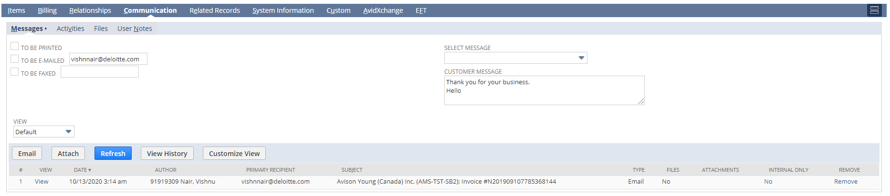

- Enter recipient, email address and additional recipient and details

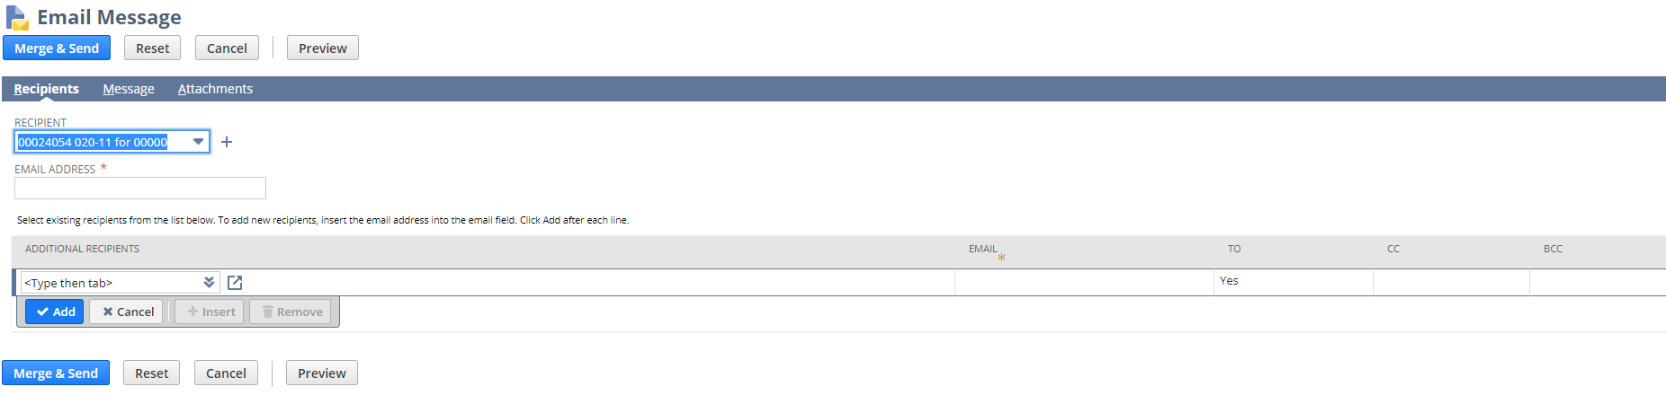
- Click on Message tab.
  - Select the template created in Automatic step above, else enter details manually.
  - Review subject, message body details and update as required.
  - Field values from invoices/ customers or any other record associated with this transaction can be added as well by selecting ‘Field Type’ and select a field in ‘Insert Field’

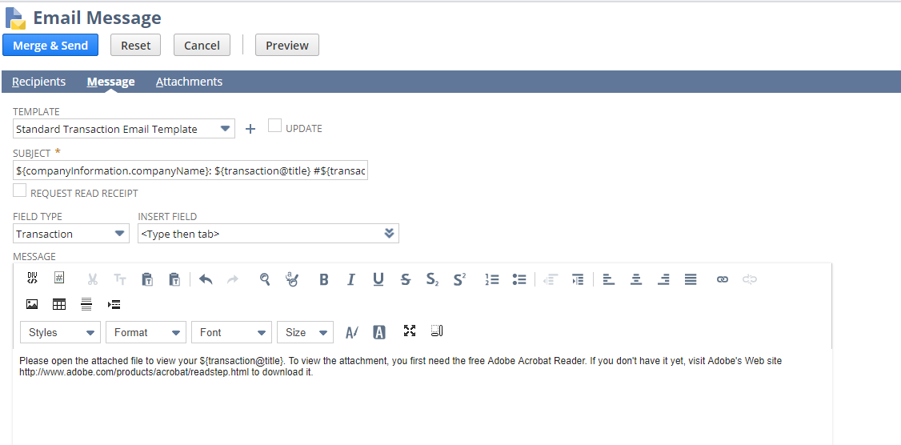
- Attachment Tab – To add additional attachments to email
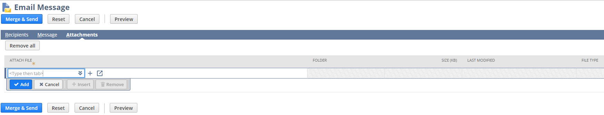

- Select a file which is already uploaded in NS file cabinet.
‘OR’
Click on plus icon next to the drop down and select an attachment from your local system.

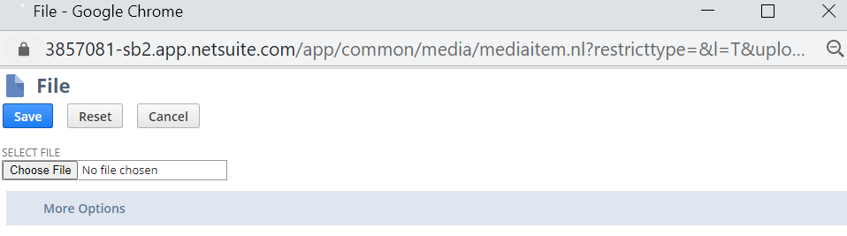
- The Invoice transaction PDF also needs to be downloaded first to local machine and follow above step to add it as attachment to Email.
- Repeat the above step to add multiple attachments.
- Once completed click on Merge and Send.

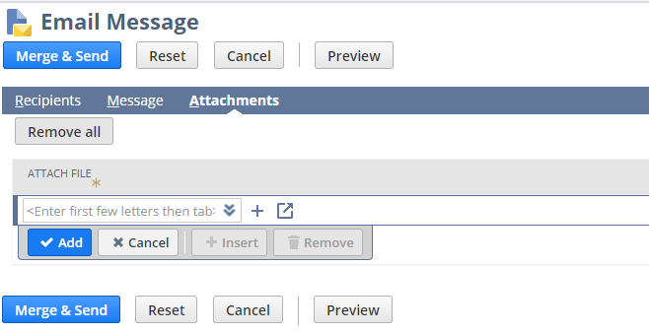

Sales Order – Invoice Attachment
Note: To email invoices created from Sales Order you enter in the request on the Sales Order. Once it is added to the sales order, invoices generated from the sales order automatically add the email address that is on the sales order.
- Navigate to Transactions>Sales>Sales Order
- Enter Sales Order Information
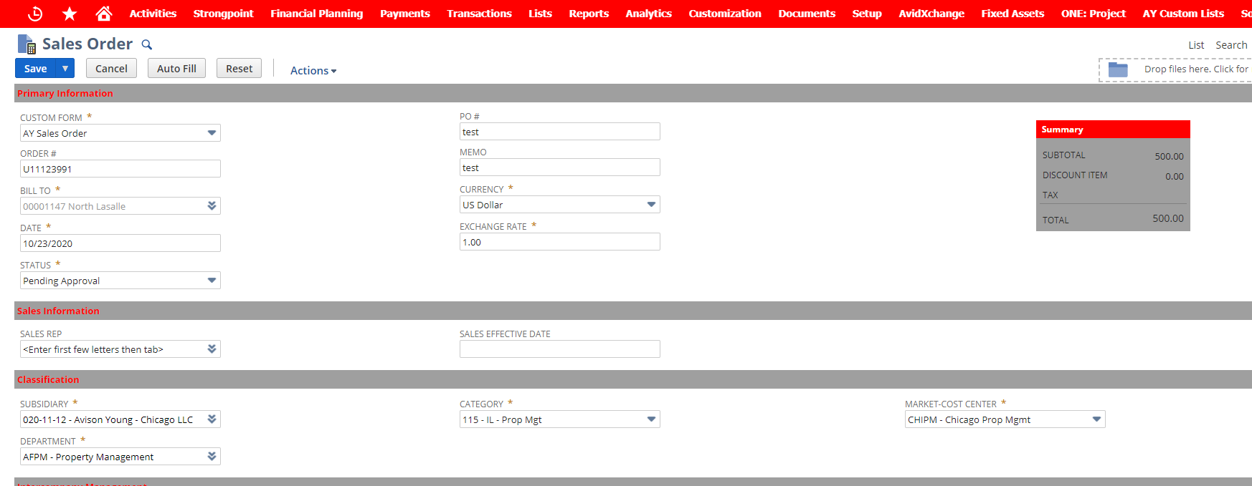
- Go to Communication tab.
- Click on To Be Emailed and Enter Email Address
- Optional: Enter Select Message & Bill To Message
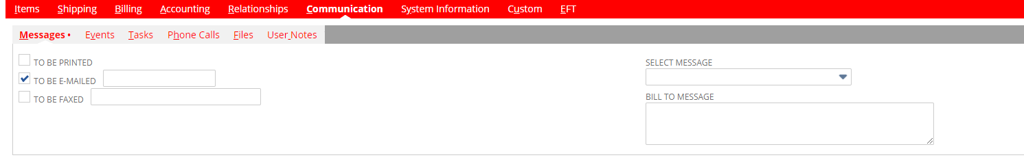

Appendix – Global Settings

Bill-To Updates:

Setup Email Defaults by Bill To’s to receive emails -Note Once this setup is done, emailing function will be defaulted for this Bill To.

Note: If you do not want to trigger an email you can disable at the invoice level or change preference for the Bill To using this instruction.

- Navigate to List> Relationship> Bill To’ s

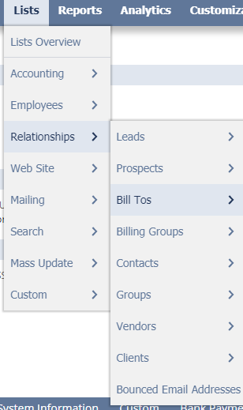

- From the list ‘Edit’ the Bill To record which needs to be setup:
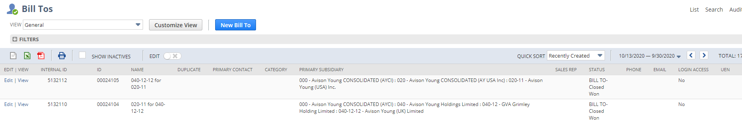

- Navigate to Preference tab and enable ‘Send Transactions via’ ‘Email’. Save the Bill To.
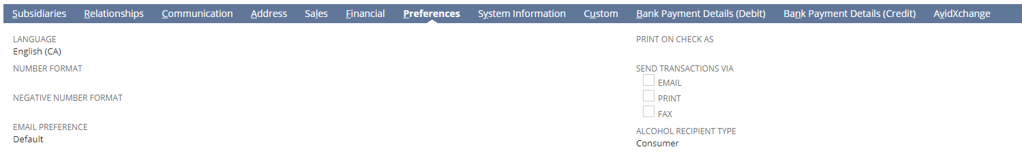

Note: If a Bill To is defaulted to receive emails, all type of invoices for that Bill To (Brokerage as well as non-brokerage invoices) would be emailed.

ADMIN TASK ONLY - Creating New Customized Email Templates – OPTIONAL
This section covers how to create a new customized Email Template.
Note – Do not modify Standard Transaction Email Template’

- Navigation: Click on Documents> Templates> Email Templates
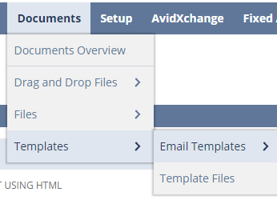

By default, system uses ‘Standard Transaction Email Template’
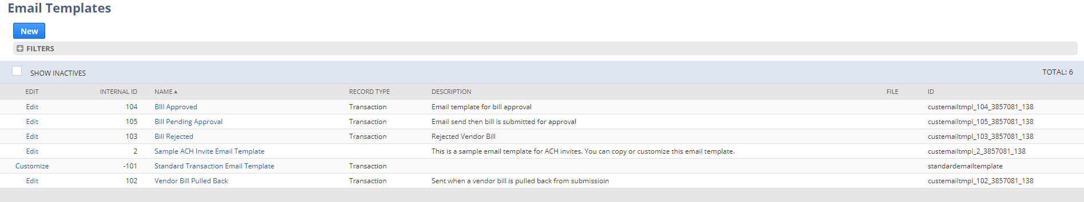

- Click on Customize to tailor email template as per requirements.
The newly customized form needs to be selected on the Invoice transaction form for system to use it.

- Navigation: Customization> Forms> customize or Edit the form to add new template
