NetSuite Support Assistant

Overview:
Basic Information:
What is the NetSuite Support Assistant?
NetSuite Support Assistant is an Oracle NetSuite Customer Support chatbot service built using the Oracle Digital Assistant (ODA) and functions as an extension of NetSuite SuiteSupport. It currently offers:
- Natural language recognition
- NetSuite SuiteAnswers integration

What can the NetSuite Support Assistant do?
NetSuite Support Assistant currently supports the following features:
- Understand natural English questions
- Provide answers from NetSuite SuiteAnswers when available
- High-level answers related to the NetSuite product
Other functionality not described above will be evaluated in later stages of development.
Where can I find documentation for NetSuite Support Assistant?
Documentation for NetSuite Support Assistant is available via:
https://system.netsuite.com/app/help/helpcenter.nl?fid=article_157443287000.html
or through this Help Center topic:
NetSuite Support Assistant (SuiteAnswers ID 89307)

Installing NetSuite Support Assistant

We encourage your employees to make use of this tool by adding the portlet to their dashboards:

- Click the Personalize Dashboard link in the Settings portlet or the Personalize link in the top right corner of the page. The Personalize Dashboard palette opens at the top of the page.
- Click the Custom Portlet icon on the Personalize Dashboard palette.
- Click the Set Up link in the portlet or the portlet menu.
- Select NetSuite Support Assistant portlet from the Source list.
- Click Save.

Using the NetSuite Support Assistant
The NetSuite support Assistant is able to provide answers from SuiteAnswers based on your queries, and high-level answers related to the specific NetSuite product area.
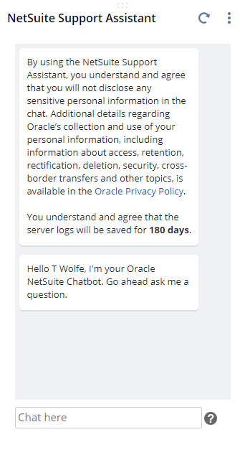
Use the chat box to type in your queries or questions. To submit, press Enter.
The portlet needs to be refreshed if an administrator has updated the Support Assistant bundle. To refresh the portlet, press the Refresh Portlet button.

Sample Queries
You can ask the Support Assistant about performing tasks in your account. The Support Assistant will then navigate you directly to the relevant page in NetSuite.
- “Show me my customers.”
- “I want to create a saved search.”
- “I want to add a new employee.”
When you ask a question about NetSuite, the Support Assistant will send you links to relevant topics in SuiteAnswers.
- “What is SuiteCommerce?”
- How can I create a SuiteBundle?”

Frequently Asked Questions

I am getting an “I don’t understand. What do you want to do?” message.
Sometimes the Support Assistant can have trouble understanding your question. Try asking in a slightly different way.

When I click on an article link, I get the alert that “Help is unavailable because your connection has timed out”. How do I resolve this?
This happens due to browser cookies from previous sessions. To solve this, clear your browser cookies by finding this option in the settings or by refreshing the page by pressing CTRL+F5.

