CSV Import AR
The steps below are used to add or update the Invoices to Netsuite through CSV Import.
Prerequisite: Login Role should have access for CSV Import.
- Template Information
The template for Invoice upload is below with sample. For an invoice with more than 1 line, the Header Fields described below remains same but will have different Line Fields.
For the below mapping, the fields marked as (can be Blank) can be left out and default values are taken. For the invoices with unique External ID, records are created and if the External ID already exists in the system, the record with that external id gets updated.

Additional fields can be included with the field name in 1st row of the csv. The line level details are added from Invoice Items and the Header fields are added from Invoice
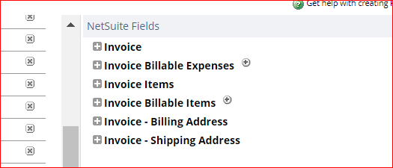

The Mapping details are as below:
Header Fields:
External ID: Invoice: External ID
Name: Invoice: Name
Date: Invoice: Date
Currency: Invoice: Currency (can be Blank)
Exchange Rate: Invoice: Exchange rate (can be Blank)
Account: Invoice: Account (can be Blank)
Sales Rep: Sales Rep (can be Blank – null by Default)
Sales Effective Date: Invoice: Sales Effective Date
Subsidiary: Invoice: Subsidiary (can be Blank)
Department: Invoice: Department
Market-Cost Center: Invoice: Location
Category: Invoice: Class
Client: Invoice: Client (can be Blank – null by Default)
Property: Invoice: Property (can be Blank – null by Default)
Deal: Invoice: Deal (can be Blank – null by Default)
Source System ID: Invoice: Source System ID (can be Blank – null by Default)

Line Fields:
Item: Invoice Items: Item
Quantity: Invoice Items: Quantity
Tax Item: Invoice Items: Tax Code (can be Blank)
Market-Cost Center (no hierarchy): Invoice Items: Location
Category (no hierarchy): Invoice Items: Class
Department (no hierarchy): Invoice Items: Department

- Steps for CSV Import
Step 1: Navigate to Setup > Import/Export > Import CSV Records
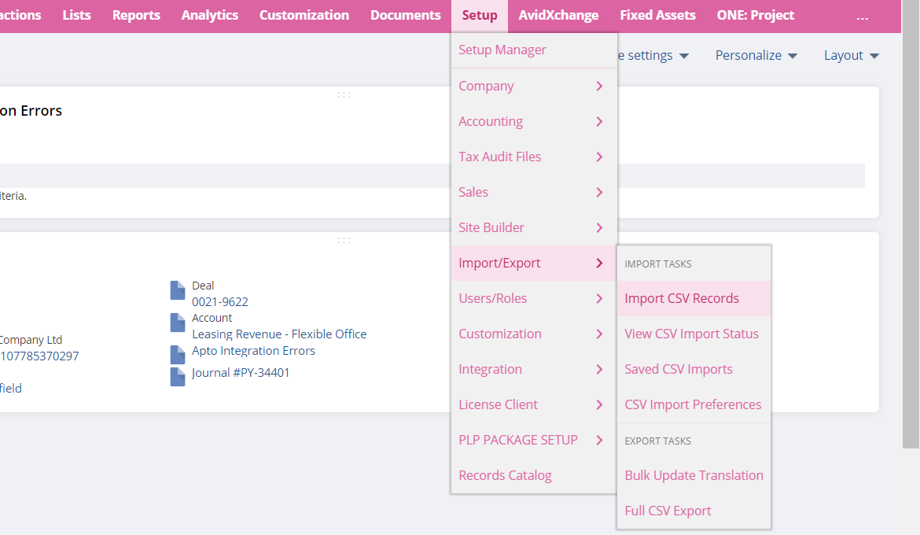
Step 2: In the Import Page, select IMPORT TYPE as ‘Transactions’ and RECORD TYPE as ‘Customer Invoice’
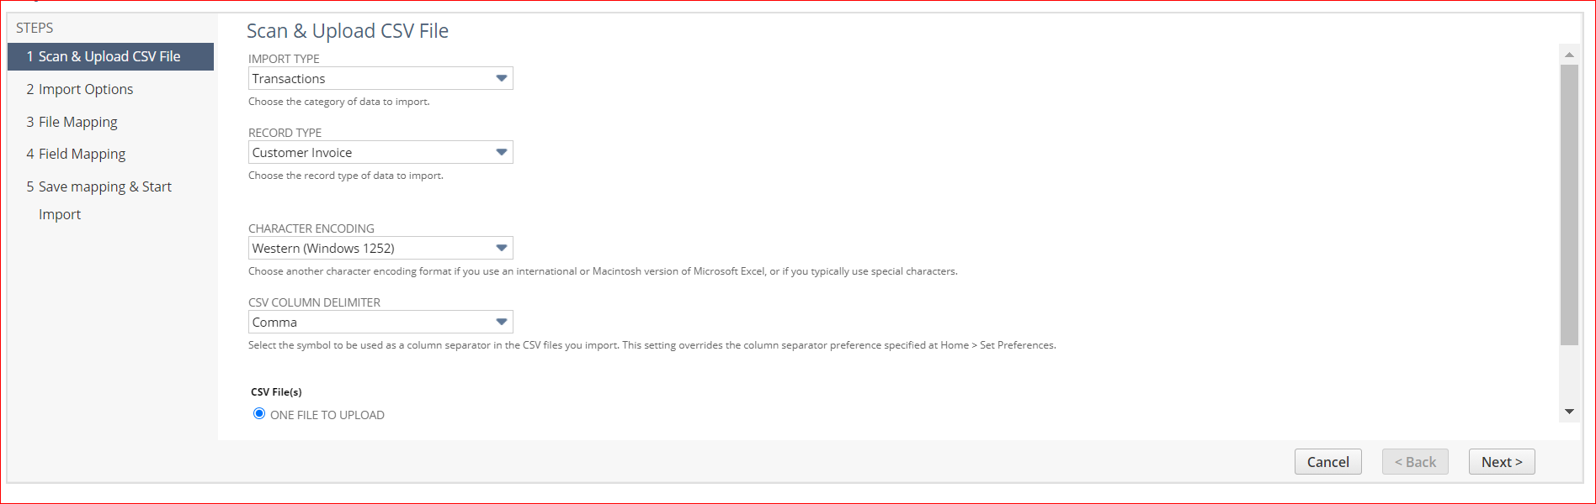
Step 3: In the same page, scroll down and click SELECT button to upload the csv file. Once file upload is complete, Click on Next.
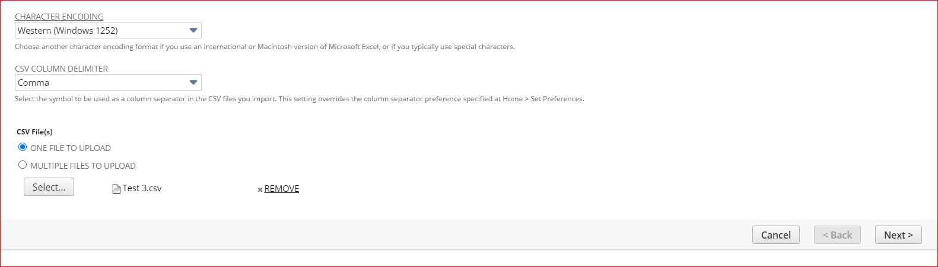
Step 4: In the Import Option page, select ADD OR UPDATE. Click Next
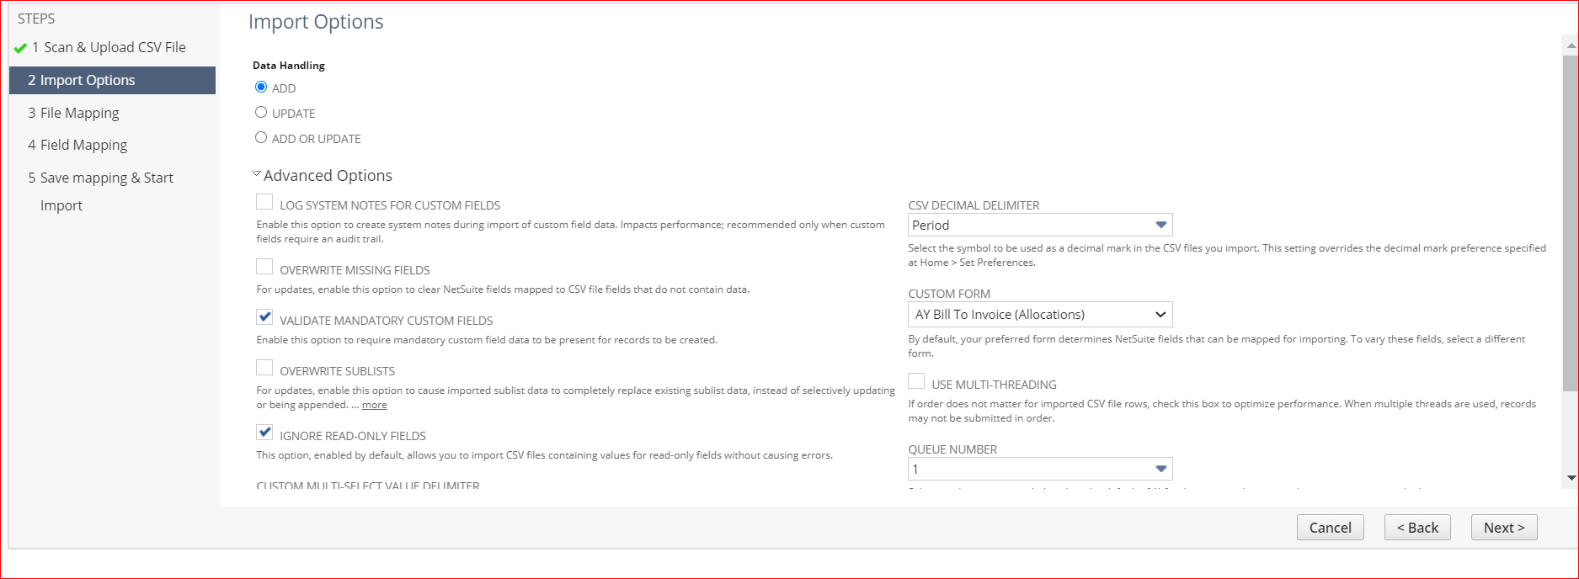
Step 5: In the Field Mapping, verify all fields are mapped correctly. In case the field value is Internal ID and not Name value, click on the pen icon on specific field (middle column) and select the value type. Once all fields are verified, click on Next.
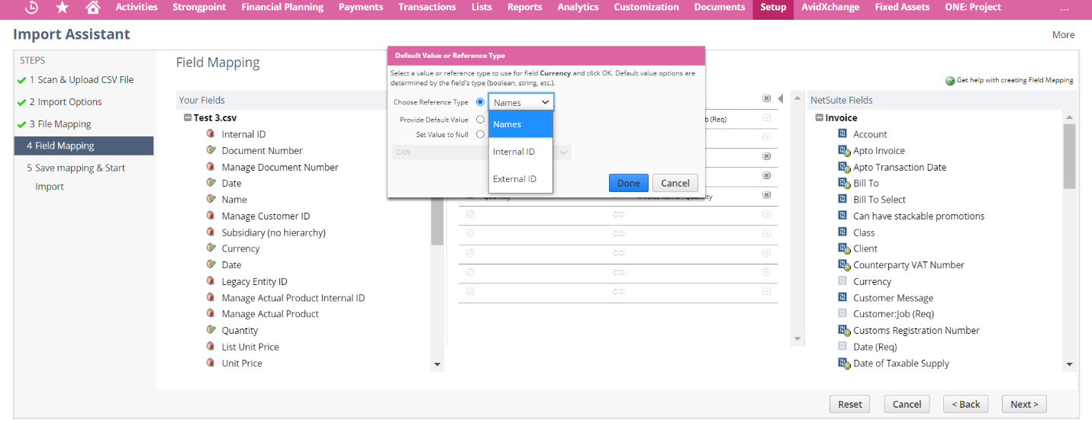
Make sure all fields are mapped as below:
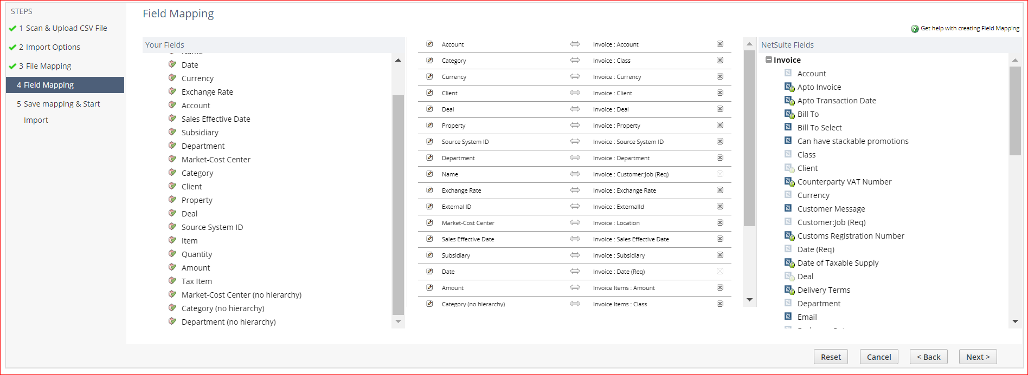
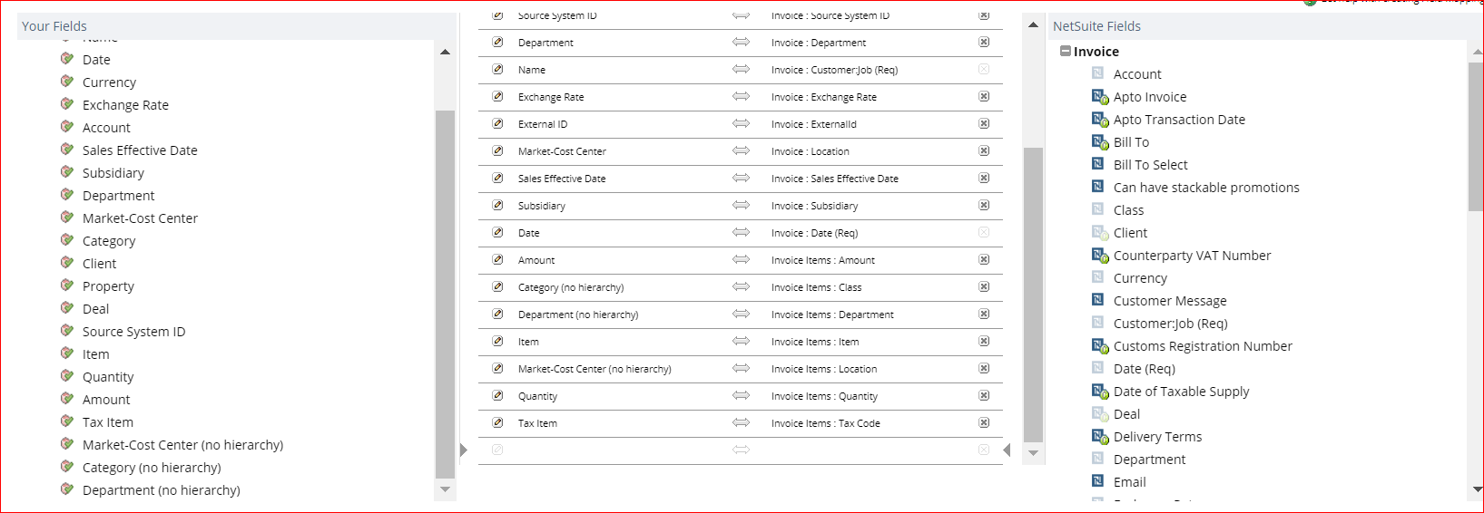
Step 6: Click on Run
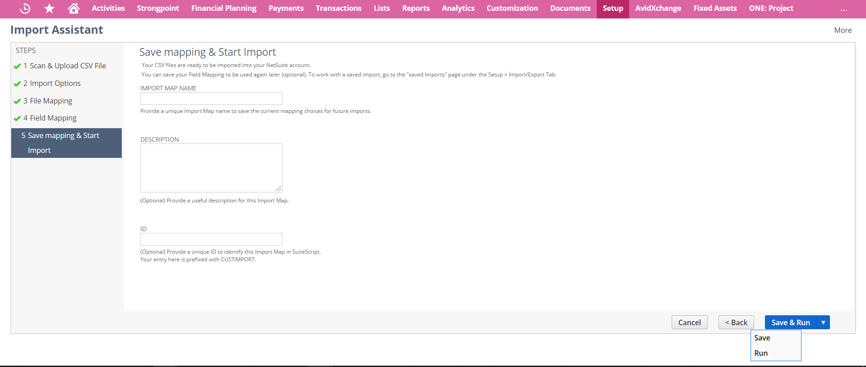
Step 7: Navigate to Setup > Import/Export > View CSV Import Status. Find the status of the CSV Import from opened page.
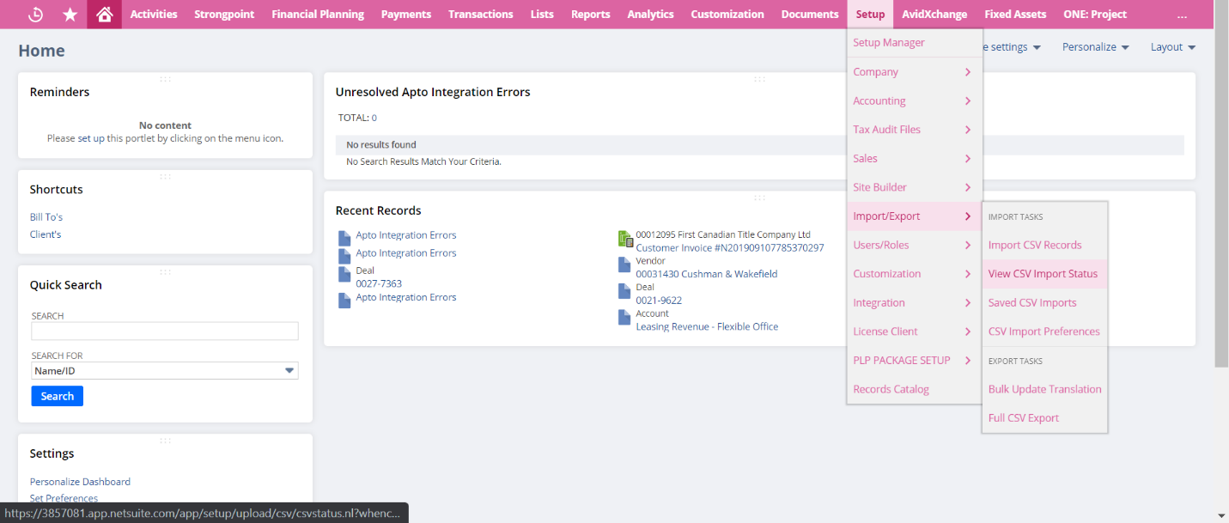
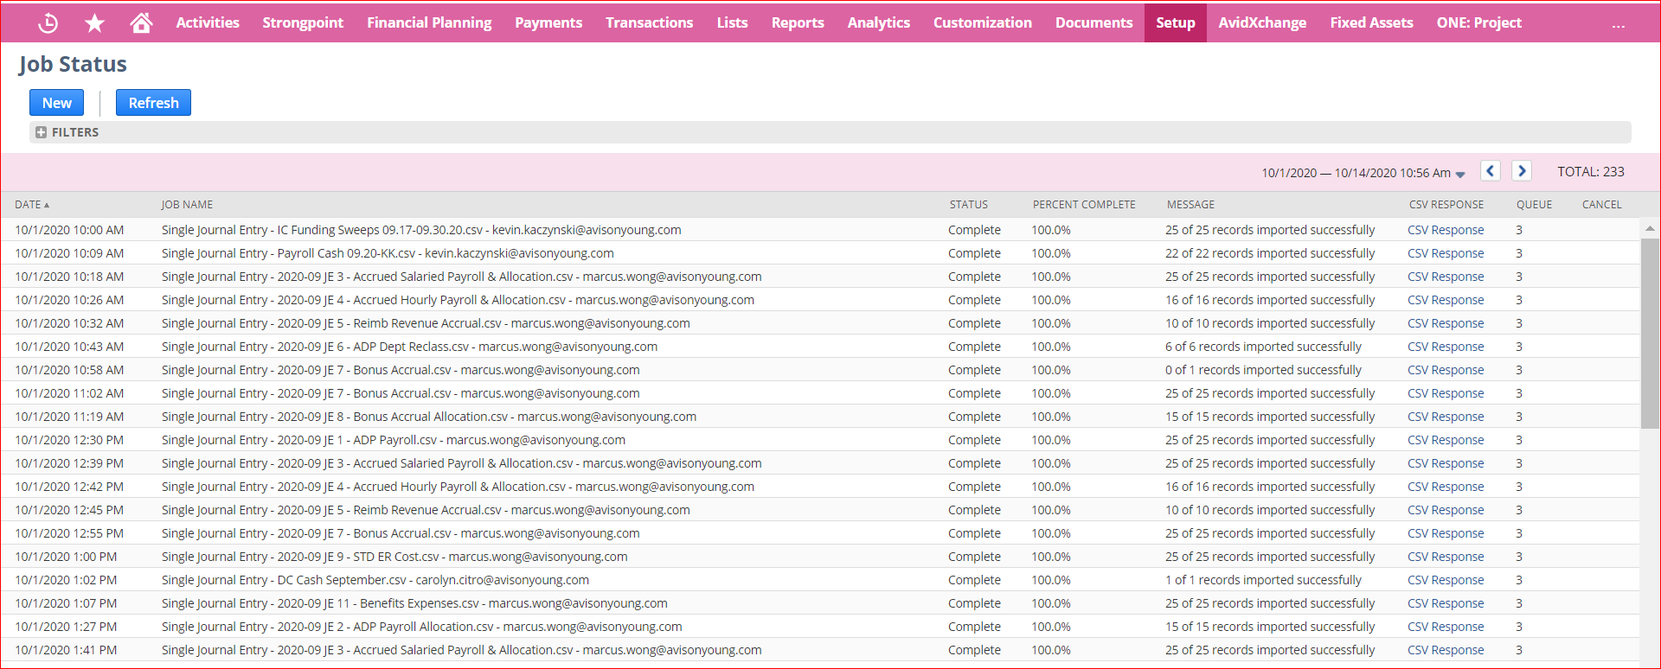

- Template Troubleshooting
Invalid Client: Client name should be the client’s ID + “Single Space” + Name (from client custom record)
Invalid Property: Property name should be the Property ID + “Single Space” + Name (from property record)

