Date & Posting adjust - CM - new Invoice issue by CSV
Adjusting the invoice by applying a Credit Memo and then issuing a new invoice (all through csv) involves 4 steps.
- Get invoice details through Saved Search
- Create Credit Memo CSV and upload - using the info from invoice export
- Apply the Credit Memo to Original invoice through CSV
- Create new Invoice from the original invoice export
Sample csv Files:

- Saved Search – Invoice details

- Navigate to Lists > Search > Saved Searches and EDIT “Invoice-Credit memo Import Search Results”. Or search in the Global search and edit the Saved Search.
- In the Criteria tab, in Internal ID field, click on the Set Description Icon  and provide the internal Id’s of all invoices that needs adjusting
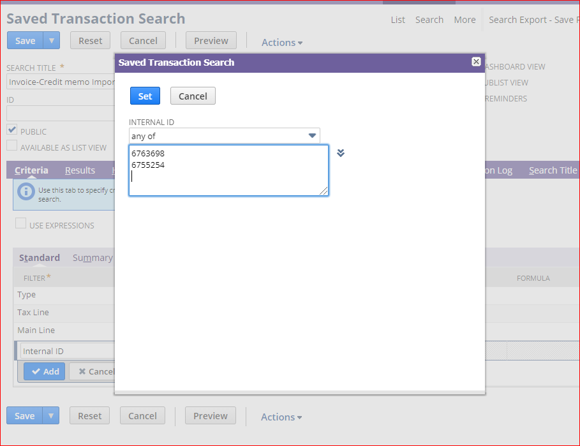

- In the Results tab, make sure all required fields are present.
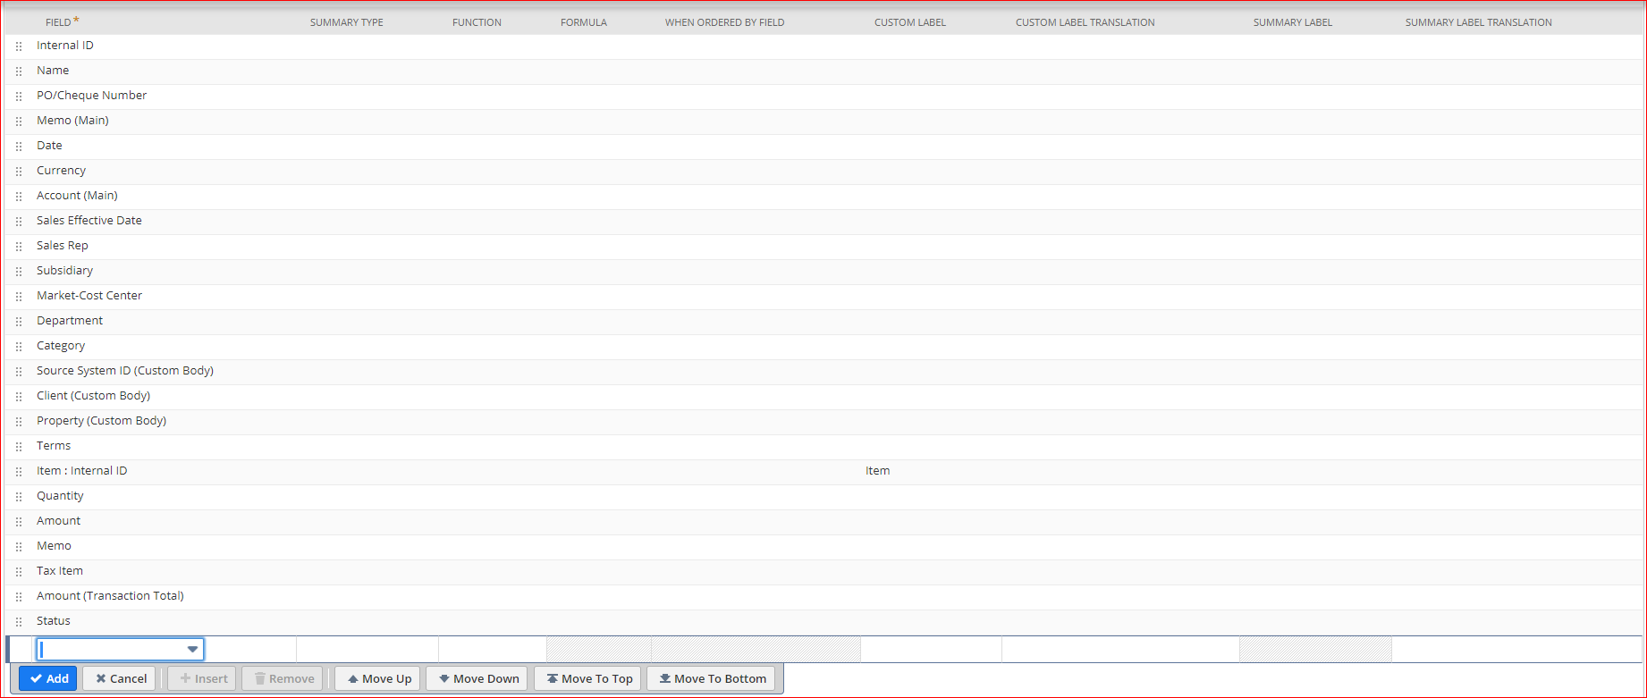
The last two fields, Amount(Transaction Total) ad Status will be for reference.
- After validating that all fields are present, click on Save and Run button.
- In the search results, click on Export as Excel icon
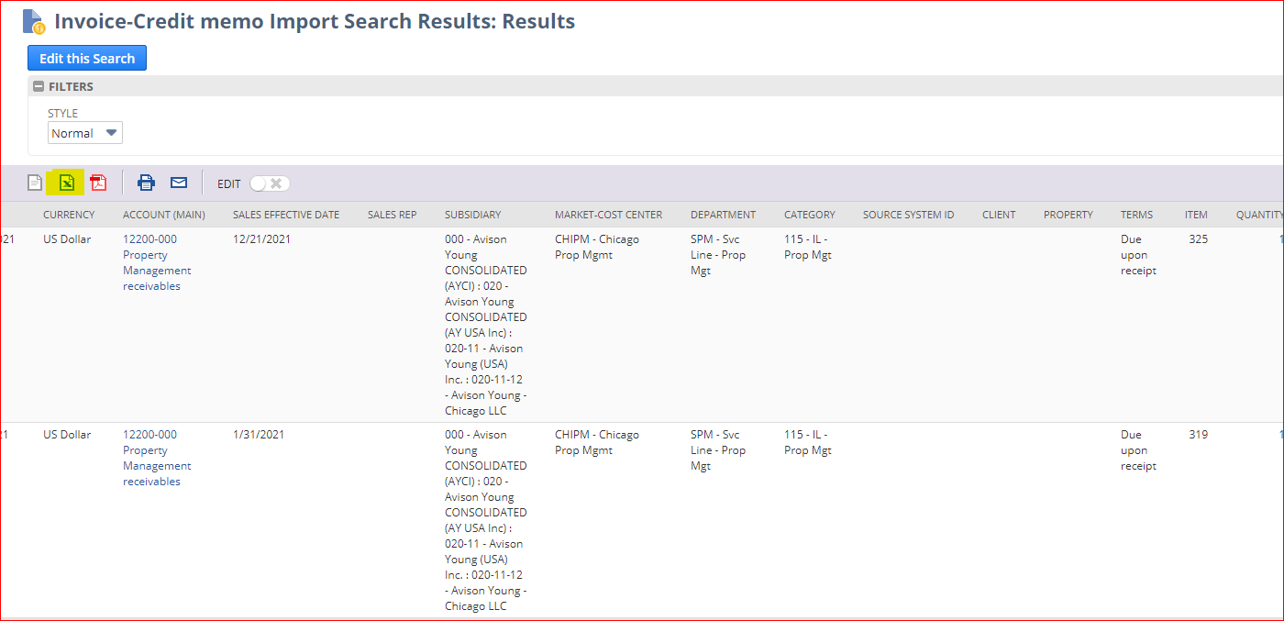

- Credit Memo CSV and Upload
- Edit the exported Excel without making any changes and click on Save As > UTF-8 Comma Separated CSV.
- Now make a copy of the same file with a different name, say “Credit Memo creation from Invoice”. The original csv will be used for re-issuing the invoice through csv and the new renamed file for Credit Memo creation.
- Edit the credit memo creation file and make sure the following fields only exists and rest are removed.
External ID, Name, PO/Check Number, Memo (Main), Account, Date, Currency, Subsidiary, Market/Cost Center, Department, Category, Client, Property, Item, Quantity, Amount, Memo, Tax Item, Amount Applied
Sample csv file: Attached csv file in page 1 : “CM Creation.csv”
Troubleshoot: Amount, Amount Applied field should not contain comma(,) or parenthesis (). Change the format to number and to not use separator.
External ID should be made unique in the new file by adding meaningful string.
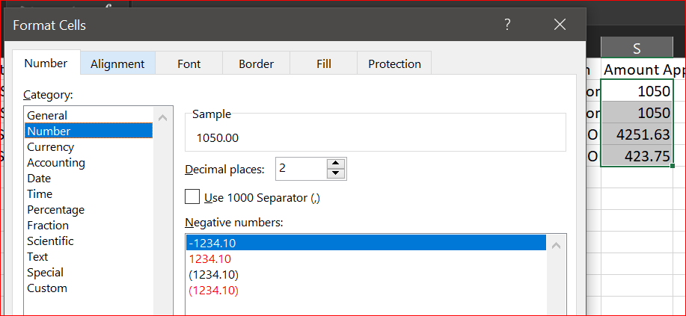
- In Netsuite, navigate to Setup > Import/Export > Saved CSV Import and open the import “Credit Memo Upload – Invoice lines”
- In Scan & Upload, click on the select button and select the Credit memo creation file and click on Next
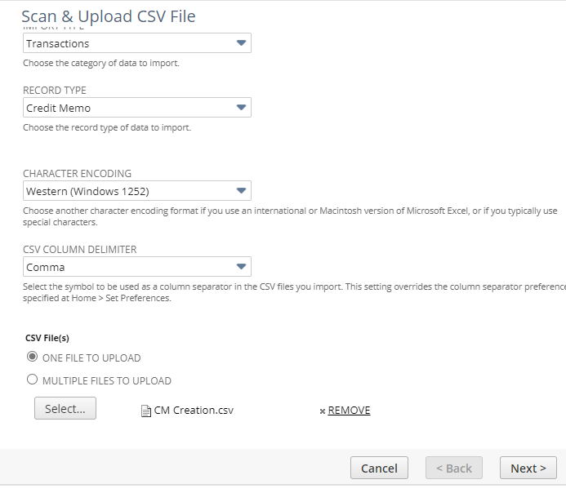
- In the Import Options, select ADD or UPDATE and click Next
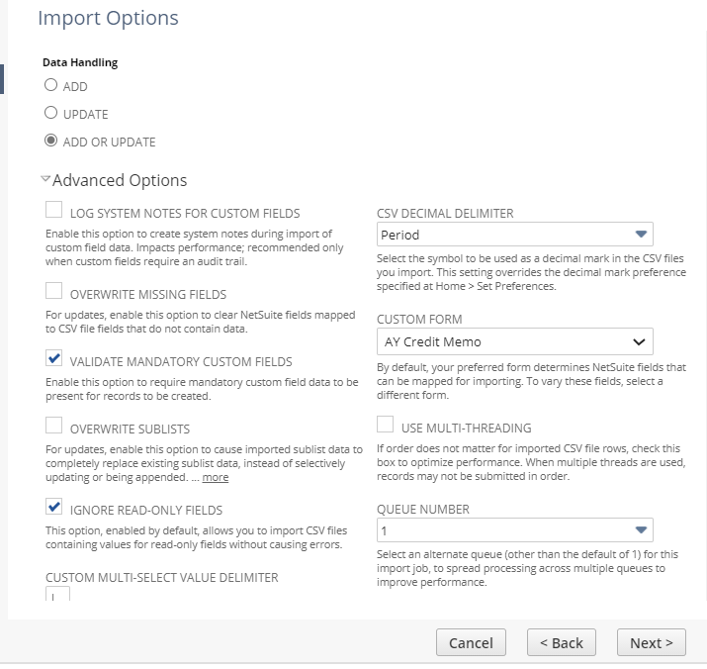
- In the mapping, make sure all fields are applied as below (leave the fields not in below list) and click on Next:
 | Account |  | Credit Memo : Account
 |  | Currency |  | Credit Memo : Currency
 |  | Client |  | Credit Memo : Client
 |  | Property |  | Credit Memo : Property
 |  | Department |  | Credit Memo : Department
 |  | Name |  | Credit Memo : Bill To
 |  | External ID |  | Credit Memo : ExternalId
 |  | Memo (Main) |  | Credit Memo : Memo
 |  | PO/Check Number |  | Credit Memo : PO #
 |  | Subsidiary |  | Credit Memo : Subsidiary
 |  | Date |  | Credit Memo : Date
 |  | Amount |  | Credit Memo Items : Amount
 |  | Item |  | Credit Memo Items : Item
 |  | Quantity |  | Credit Memo Items : Quantity
 |  | Tax Item |  | Credit Memo Items : Tax Code
 |  | Memo |  | Credit Memo Items : Description
 |  | Market/Cost Center |  | Credit Memo : Location
 |  | Category |  | Credit Memo : Class

The Credit Memo: Posting period has to be selected and as a new mapping and by clicking on the the pen icon, the default value has to be set to the Posting period required. Eg. Dec 2020 because some users (Administrators) will be able to post to the previous period.
- Click on Run, from Save, Save & Run dropdown
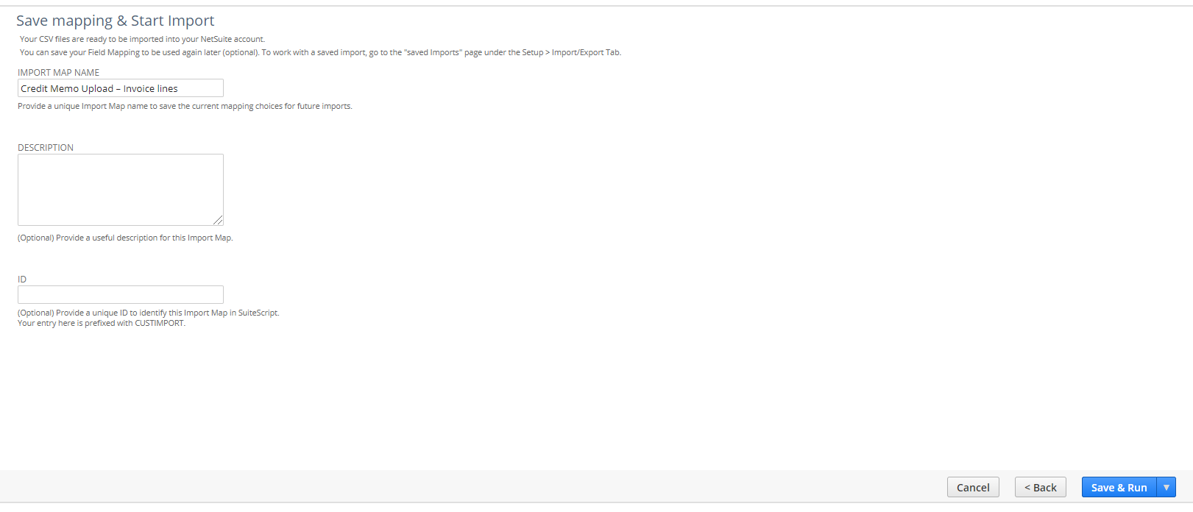
- To know the status of the import, click on the Import Status Page on the Confirmation message or navigate to Setup > Import/Export > View CSV Import Status

- Apply the Credit Memo to Original invoice through CSV

- Create a new CSV file in the following format:
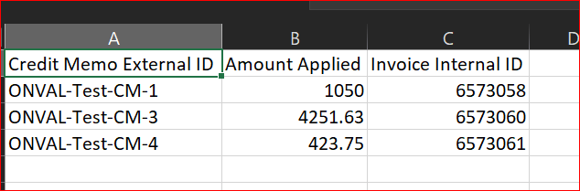
Troubleshoot: Amount Applied field can be got from Credit Memo creation file – Amount (Transaction total) and should be renamed as above.
Invoice Internal ID field will be from Invoice Internal IDS field from previous csv.
Credit Memo External Id will be from Credit Memo creation file – which was made unique by customer.
- In Netsuite, Navigate to Setup > Import/Export > Saved CSV Import > and open “Credit Memo Upload – cm apply to invoice”
- Click on Select button and upload the CM Invoice Apply.csv and click Next
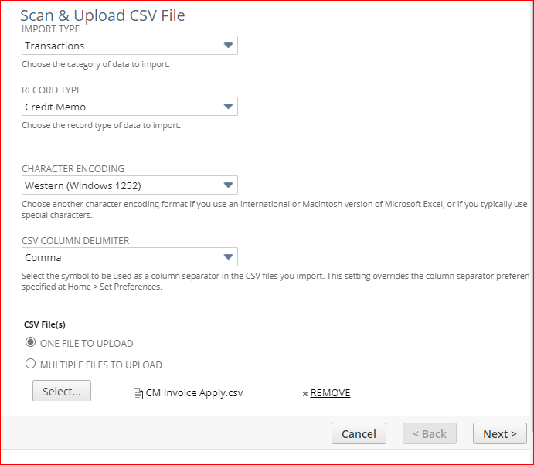
- Select UPDATE and in Advanced Options, make sure RUN SERVER SUITESCRIPT AND TRIGGER WORKFLOWS is unchecked and click on Next
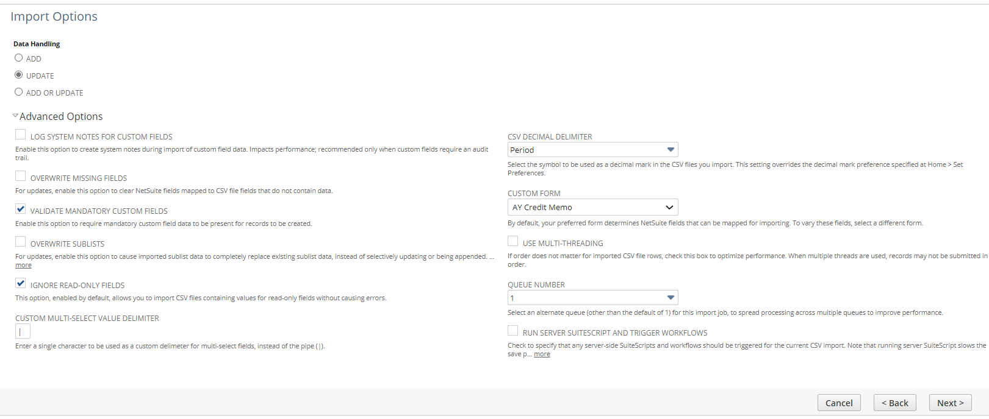
- Mapping as below and once verified, click on Next:
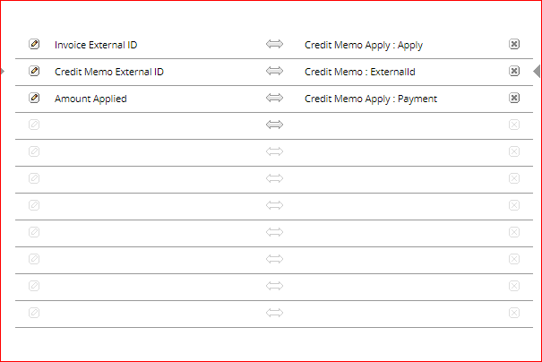
- Click on Run, from Save, Save & Run dropdown
- To know the status of the import, click on the Import Status Page on the Confirmation message or navigate to Setup > Import/Export > View CSV Import Status
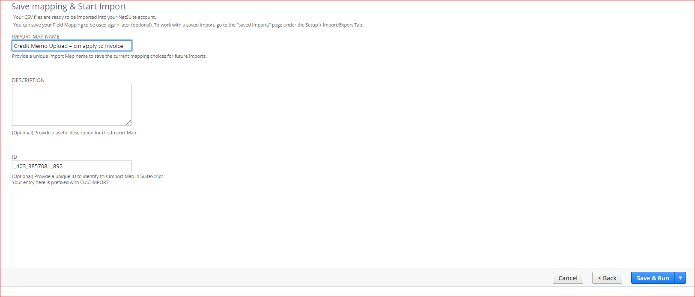

- Create new Invoice from the original invoice export
- Open the original saved search export again and this time rename the field Internal ID to External ID and make the external ID unique.
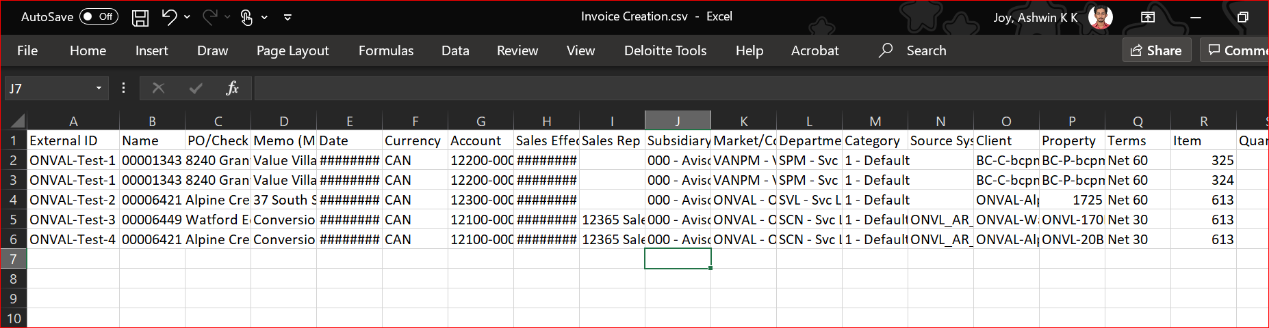
- Edit the fields Date for Transaction Date, Terms to adjust the Due Date.
Troubleshoot: make sure the required Terms (Net 30, Net 60, Net 365…) is already present in Netsuite system before csv import.
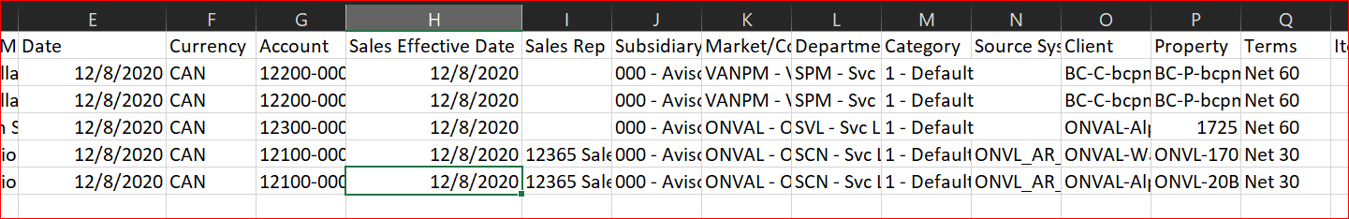
- Navigate to Setup > Import > Saved CSV Import and open “Invoice Upload – Date & Posting by Terms”
- Select the file and click on Next
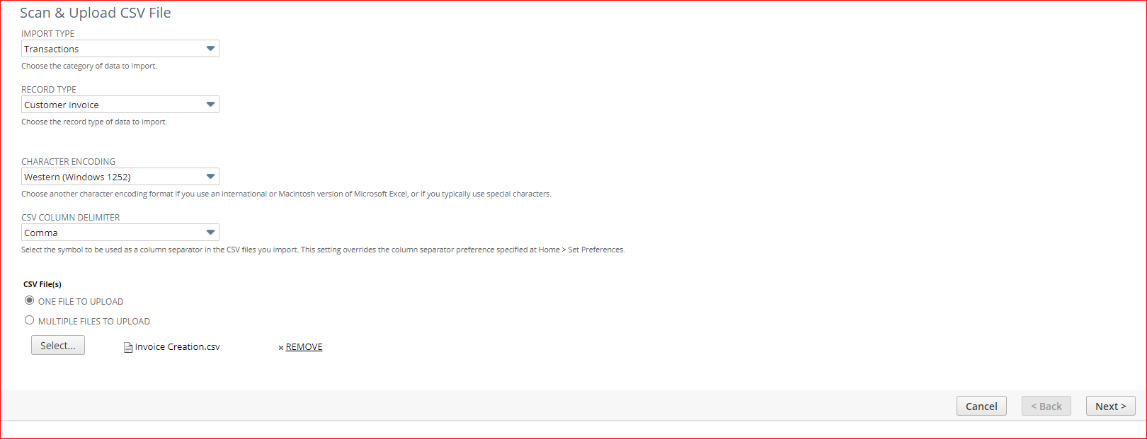
- Select ADD and click on Next
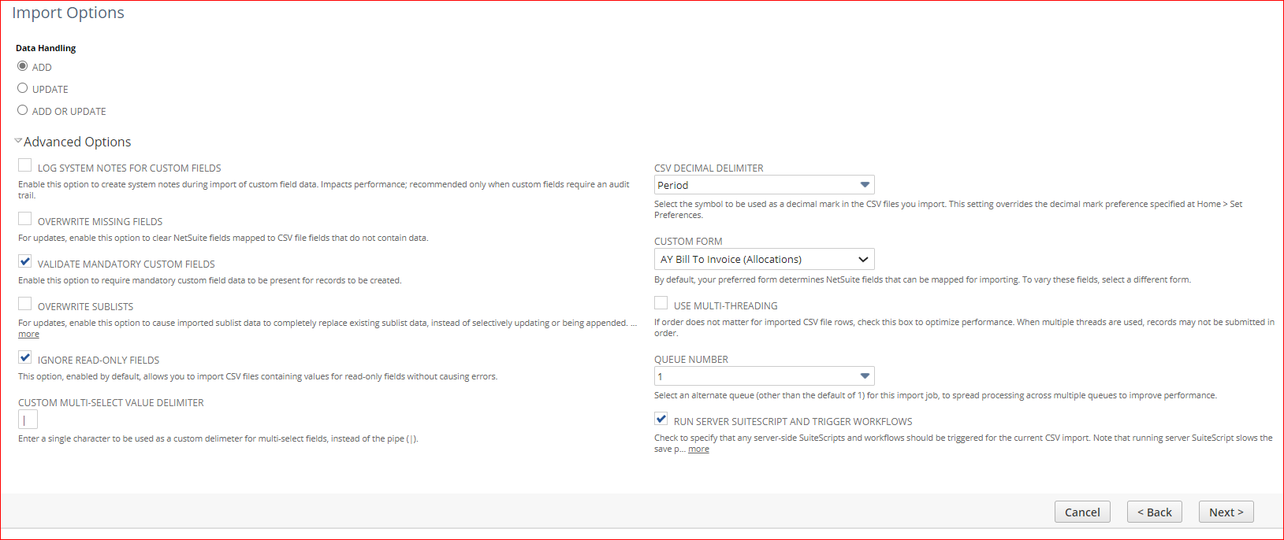
- Validate the mapping as below and click on Next
 | Account |  | Invoice : Account
 |  | Currency |  | Invoice : Currency
 |  | Client |  | Invoice : Client
 |  | Property |  | Invoice : Property
 |  | Source System ID |  | Invoice : Source System ID
 |  | Department |  | Invoice : Department
 |  | Name |  | Invoice : Customer:Job (Req)
 |  | External ID |  | Invoice : ExternalId
 |  | Memo (Main) |  | Invoice : Memo
 |  | PO/Check Number |  | Invoice : PO #
 |  | Sales Effective Date |  | Invoice : Sales Effective Date
 |  | Sales Rep |  | Invoice : Sales Rep
 |  | Subsidiary |  | Invoice : Subsidiary
 |  | Terms |  | Invoice : Terms
 |  | Date |  | Invoice : Date (Req)
 |  | Amount |  | Invoice Items : Amount
 |  | Item |  | Invoice Items : Item
 |  | Quantity |  | Invoice Items : Quantity
 |  | Tax Item |  | Invoice Items : Tax Code
 |  | Market/Cost Center |  | Invoice : Location
 |  | Category |  | Invoice : Class
 |  | Memo |  | Invoice Items : Description

The Credit Memo: Posting period has to be selected and as a new mapping and by clicking on the the pen icon, the default value has to be set to the Posting period required. Eg. Dec 2020 because some users (Administrators) will be able to post to the previous period.
- Click Run, from Save, Save & Run dropdown.
