AY Project Import Template
Columns in Excel:
Internal ID : Column A for Project updates. If internal ID field is blank, new project is created.
Project Name (Auto-generated) : Column B auto-generated with value from Market-Cost Center + Project Name which is column D + column C.
Project Name (Required) : Column C required field for Name (ID)
Market-Cost Center (Required) : Column D required field for Project MCC
Associated Bill To ID (Required) : Column E required for Associated Bill To. Bill To ID + Name required. “00026099 Asden Canada”
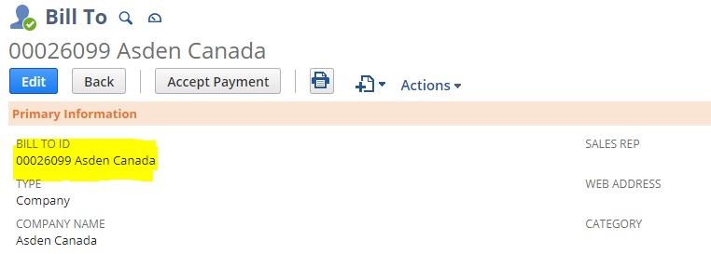
Associated Client ID (Required) : Column F required for Associated Client. Client ID required. “00021583”. The Client and Bill To should have preceding Zero ( “0” ) as available in Netsuite environment – Format cells in column F (Client) as TEXT in excel.
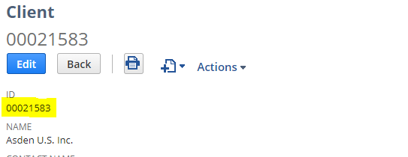
Project Address 1(Required): Column G is Address Line 1 for Address
Project City (Required) : Column H is Address City
Project State (Required) : Column I is Address State. This should be full name. Ex: “New Jersey” and not NJ.
Project Zip Code (Required) : Column J is Address Zip Code
Subsidiary Countries: Column used to update available subsidiaries depending on the Country. Set the value as “Canada” or “United States” depending on Country. If the Property is required for both subsidiaries, use | (pipe symbol) to add the necessary Countries. Ex: Canada | United States

Steps:
Step 1 : Add the fields as required in template. Copy and Paste formula in Column A and J as project upload line count increases. The Client and Bill To should have preceding Zero ( “0” ) as available in Netsuite environment – Format cells in column F (Client) as TEXT in excel.
Sample Template:
Step 2 : Click on Save As and save the file with CSV format.
Step 3 : Navigate to Setup > Import/Export > Saved CSV Import. Find “ New Project Import Multi-subsidiary CAN” for Canada Project import and “New Project Import Multi-subsidiary US” for US project import.
New Project Import Multi-subsidiary US
New Project Import Multi-subsidiary CAN

Step 4 : In the CSV Import page, click on SELECT and upload the CSV file. Click on Next
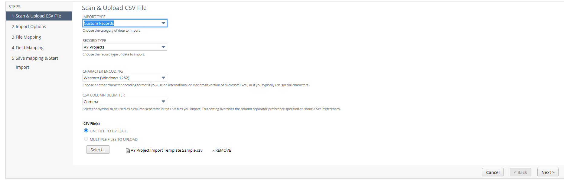
Step 5 : In the Import Options page, validate the selected value is Add or Update. Click Next
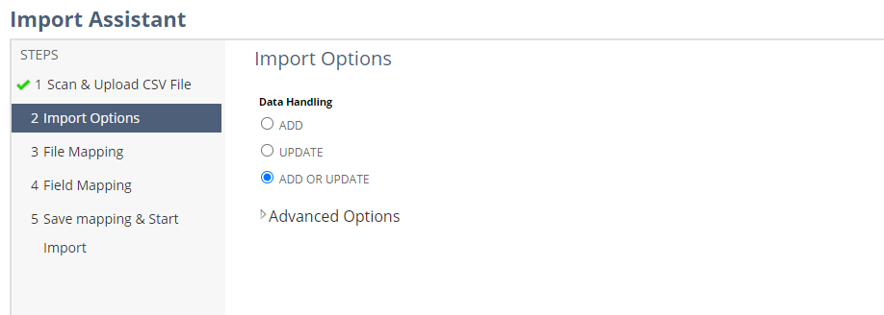

Step 6 : The Project Subsidiary is defaulted to have all subsidiaries of that specific country depending on the CSV Import (CA or US).
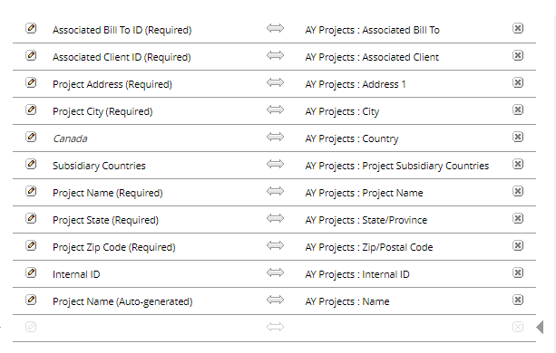
Country will be defaulted to United States for US CSV Import and Canada for CAN CSV Import.
Click on Next
Step 7 : Click on Run.
Step 8 : The status of CSV can be found in “View CSV Import Status”

