Scheduling Saved Searches
Step 1: Open the required saved search
Step 2: Make sure you are the owner of the saved search. If you are not the owner of the search you cannot schedule a search and system gives a warning message saying “Only the owner can schedule a saved search. You must log in as the owner and save the search for it to be scheduled.”
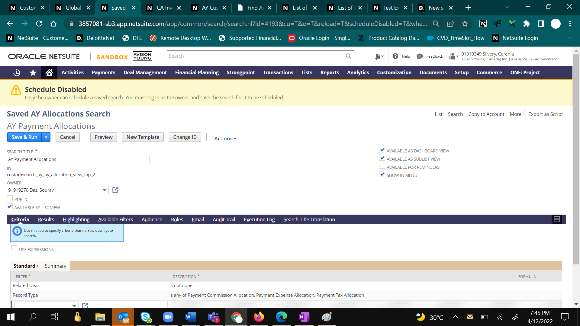
Below highlighted is the owner field.
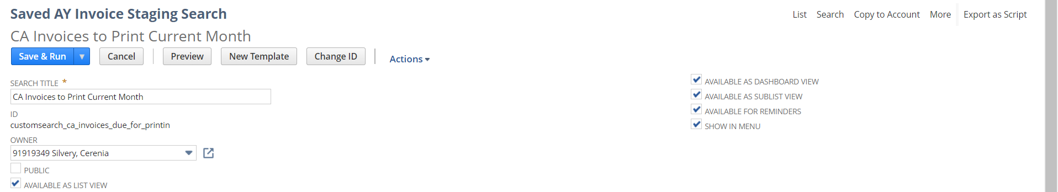
Step 3: Under the Email tab, click on the “schedule” tab. In this section, select if it is a Single, Daily, Weekly, Monthly or Yearly event.
If it is a weekly event select which day of the week the report should be sent and enter the Repeat every 1/2/3 and so on weeks as shown below.
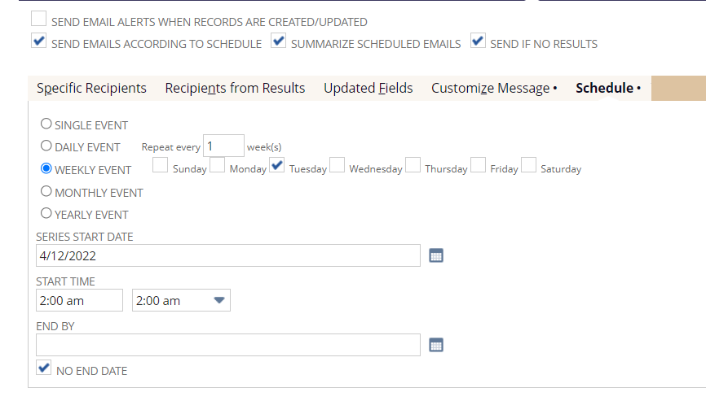
If it is a daily event select Repeat every 1/2/3 and so on days or Repeat every weekday.
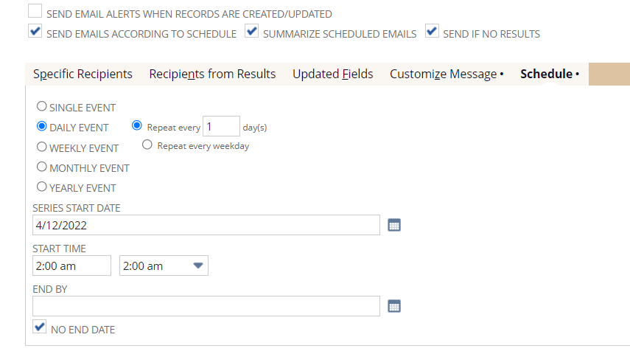
If it is monthly event, select day of the month or 1st, 2nd and so on weekday of every 1 month as shown below.
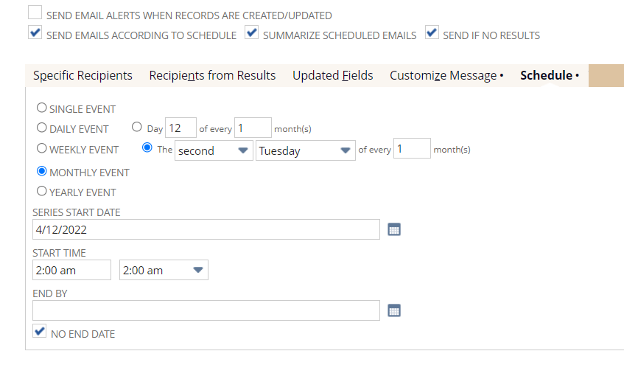
If it is yearly event select the repeat month and day or 1st, 2nd and so on weekday of every a month as shown below.
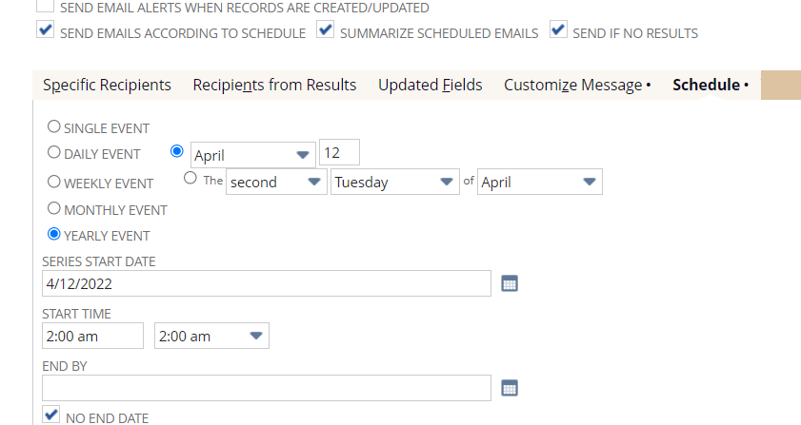
- For a monthly event, the day in the Start Date for example 9-8-2021 should match the selection in the option buttons. In this example, you should enter 8 for Day, if this option is selected, or select the second Wednesday.
- For a weekly event, the day of the Start Date should match the selected day of the week. In this example, you should check the Wednesday box.

Step 4: Enter the Series Start Date and set the Start Time when the report should be sent. The End By date should be selected if there this should be scheduled for only a specific time period otherwise select “No End Date” checkbox.
Step 5: To customize the alert/ scheduled email message, click on the Customize Message tab. Use this tab only if the message or alert requires to be customized from what the standard or default template.
From field: Enter an optional sending email address.
Use the following format: “name” <email address>.
If this field is blank, emails are sent from the search owner's email address, as defined in the Email field on their employee record.
If this field is blank, and no email address is defined on the search owner's employee record, emails are sent from the email address set in the Return Email Address field at Setup > Company > Company Information.
Subject: Enter optional text to appear in the Subject field of alerts and scheduled emails. If you do not enter text here, default text appears in this field.
In the big text box, you can enter a custom message. This message can include dynamic values but this document does not cover how to enter dynamic values in a message.
Summarized Results:
You can select if the report should be sent as CSV or XLS or PDF. You can also check “Include view Record Link” if you want users to allow to see the search results in NetSuite UI.
Step 6: Under Specific Recipients tab you can select the specific recipients to receive the report. If it should be BCC you can check the BCC box for the recipient.
Under the “Recipients from the Results tab” you can select the field for example Bill To as a recipient. This will be dynamic and updates based on the results. Select recipient using this tab only if you wish to send to recipients/users from the search results.

